**Project Report**

On

“Smart Line follower Robot With Vanet”

Submitted by

Mr.Singh Ashish Shrinath(T-16-0287)

Mr.Thaware Sairaj Maruti(TD-17-0469)

Mr.Savarkar Rushikesh Ganesh (TD-17-0407)

Ms.Ghag Sayali Ramdas(TD-17-0510)

Ms.Hardikar Rucha Sanjay(T-16-0158)

Ms.Kubal Smitali Tulsidas(TD-17-0520)

Under the Guidance of

Prof. Suraj Shete

Assistant Professor

Dept. of Electronics Engg.

**Department of IT Engineering**



**Finolex Academy of Management and Technology's,Ratnagiri.**

|  |  |  |
| --- | --- | --- |
| **Finolex Academy of Management and Technology, Ratnagiri.**  **Project Report**  **for**  **Department wise Best Project Award Competition** Academic year 2018-2019 | | |
|  | **Department** | Information Technology |
|  | **Name of Program** | T.E.(Information Technology) |
|  | **Project Topic** | Smart Line Follower Robot With Vanet |
|  | **Name and Signature of Students** | 1. Mr. Singh Ashish Shrinath _________ 2. Mr. Thaware Sairaj Maruti _________ 3. Mr. Savarkar Rushikesh Ganesh _________ 4. Ms.Ghag Sayali Ramdas _________ 5. Ms.Hardikar Rucha Sanjay _________   6.Ms.Kubal Smitali Tulsidas _________ |
|  | **Name and Signature of Guide** | Prof.Shete Suraj _________ |
|  | **External Examiner Signature** |  |

**CONTENTS**

Page No.

*Participant’s Declaration* *i*

*Acknowledgement* *ii*

*Nomenclature* *v*

*Abstract vi*

**Chapter 1: INTRODUCTION**

**Chapter 2:LITERATURE REVIEW**

**Chapter 3:PROJECT WORK**

**Chapter 4: RESULTS AND DISCUSSION**

**Chapter 5: CONCLUSIONS AND FUTURE SCOPE**

**REFERENCES**

**DECLARATION**

We declare that, this written submission represents our ideas in our own words and where others ideas or words have been included, we have adequately cited and referenced the original sources. We also declare that we have adhered to all principles of academic honesty and integrity and have not misrepresented or fabricated or falsified any idea/data/fact/source in our submission. We understand that any violation of the above will be cause for disciplinary action by the Institute and can also evoke penal action from the sources which have thus not been properly cited or from whom proper permission has not been taken when needed.

Mr. Singh Ashish Shrinath

Mr. Thaware Sairaj Maruti

Mr. Savarkar Rushikesh Ganesh

Ms. Ghag Sayali Ramdas Ms. Hardikar Rucha Sanjay Ms. Kubal Smitali Tulsidas

**ABSTRACT**

This project is designed to build a Smart Robot for follow the line using IR sensor’s and avoid obstacle while following the line using ultrasonic sensor. The IR sensor is meant to trace a particular line and Ultrasonic sensors are meant to detect obstacles which it encounters. This kind of robot should change the line with its infrared Ray sensors that installed under the robot. Obstacle avoidance robot is designed to allow robot to navigate in unknown environment by avoiding collision. Robot has sufficient intelligence to cover the maximum area of space provided. The base of the robot is Arduino UNO R3 which is a microcontroller board based on the AT mega 328.It is self operating robot.This project is developed to know the easy combination of Software and Hardware.

**Keywords** –

1. IR sensor
2. Ultrasonic sensor
3. Arduino UNO-R3

**1. INTRODUCTION**

* 1. **Introduction:**

In this recent days many line following robots have been design and utilized. Line follower robot is autonomous that means it automatically follows the line which is predefined. Generally it follows the black line on white surfaces. Some of the basic operation of line follower is as follows:

* Sense the predefined line by IR sensor which is mount on the robot and send sensed signals to the arduino. The ATmega microcontroller analyses this signals and perform particular operation.
* The steering mechanism is simple in this robot. Three wheels are used out of those two wheels are on the back side of robot. This wheels are connected to motor and are operate separately and one wheel is on front middle part of the robot.
  1. **Aim and Objectives:**

The robot must be capable of following line:

* It should be capable of tacking carious degrees of turns.
* The robot must be capable of following a line even if it is breaks.
* The robot must be reliable.
* Scalability must be a primary concern in the design.
  1. **Problem Definition:**

In the industry carrier are required to carry products from one manufacturing plant to another which are usually in different building or separate blocks. Conventionally carts or truck were used with human drivers. Unreliability and inefficiency in this part of the Assembly line from the weakest link. The project is to automate this sector using carts to follow a line instead of laying railway tracks which are most costly and an inconvenience.

* 1. **Scope of Project:**

Robot can be further enhance to let the user decide whether it is a dark line on a white background or white line on a dark background. The robot can be programmed to decide what kind of time it is instead of user interface. The motor control could be modified to steer a conventional vehicle and not require a differential steering system. The sensors could be attached to allow the robot to detect obstacles and if possible by pass it to and get back to the line.- In other words it must be capable of predicting the life beyond the obstacle. Speed control could be also incorporated. Position and distance sensing devices could also be built in which can transmit information to another station which would be useful in tracking a lost carrier.

**2. LITERATURE REVIEW**

In recent years great deal of time and efforts has been spent for developing systems to enable autonomous robot to follow a marked path using vision system. Due to large amount of space available in the ordinary road vehicle, high performance computers can be used to perform complex image processing and typically to maintain a mathematical model of the vehicle and environment.

This project is implemented the concept of line following robot have referred from:-

1. Line follower Robot Design and Implementation:

[https://www.researchgate.net/publication/224132741_A_line_follower_robot_from_design_to_implementation_Technical_issues_and_problems](https://www.researchgate.net/publication/224132741_A_line_follower_robot_from_design_to_implementation_Technical_issues_and_problems%20%20)

2)Line follower and obstacle avoidance robot using Arduino:

<http://www.digitalxplore.org/up_proc/pdf/299-149664309721-24.pdf>

3)A Line Follower Robot Using Sophisticated Sensor Approach:

<https://www.researchgate.net/publication/264195178_Line_Follower_Robot_Using_A_Sophisticated_Sensor_Approach>

**3. PRESENT WORK**

**3.1 Transmitter Robot**

We follow the simple logic to implement Line following Robot. As we know that black color is capable of absorbing the radiation and white color reflects the radiation black. Here we use3 pairs of IR TX and Rx. This robot uses IR sensor to sense the line and arrangement is made such that sensor face the ground. The output from the sensor is an analog signal which depends on the amount of light reflected back and this analog signal is given to comparator to produce 0’s and 1’s..

Components used in this project:

1)**The Chassis and the Body:**

They are the parts which holds the systems and wheels will move with the help of motor.

2)**IR sensor:**

As the name suggest it senses the infrared rays.So it can also be helpful in detecting the motions and heat of an object or person.

3)**Arduino UNO:**

It is an open source platform used for building projects.

4)**BO Motors:**

This are the low voltage operating motors for driving the vehicles.

5**) Motor driver or shield:**

Motor Driver acts like the current amplifier. It controls the f low of current in the motor. Arduino board is not capable of providing direct current to the motors so to amplify current motor driver is used.

**3.2 Receiver Robot**

This robot consist of 2 modes.

1. **Obstacle Detection**

The line follower is simulated using two IR sensors placed just in front of the robot and the directions are guided through the turning OFF and ON of the IR sensors. When obstacle is come in front it then the robot is stopped and send the signal to Receiver robot. Then Receiver robot is also stopped.

Ultrasonic Sensor :

The ultrasonic sensor is attached in front of the robot. Whenever the robot is going on the desired path the ultrasonic sensor transmits the ultrasonic waves continuously from its sensor head. Whenever an obstacle comes ahead of it the ultrasonic waves are reflected back from an object and that information is passed to the Arduino. The Arduino controls the motors left, right, back, front, based on ultrasonic signals.

1. **Bluetooth Controlled Robot with android application**

The Bluetooth module helps us in forming an interaction between our robot and the android phone. Connections are made on the Arduino with the Bluetooth module and it is interfaced with the phone using an android application.. If the Bluetooth module is connected to any android device, commands can be received from the phone. The Arduino board further drives the motors which produce motion in the desired direction.

HC-05 Bluetooth Module:

A Bluetooth module is a module designed for transparent wireless serial connection setup. HC-05 Bluetooth module is used in a robot controlled via Bluetooth to establish communication between mobile phone and the Arduino.

**Programming Code**

* **Receiver Robot Code :**

int pinmode = 6;

int trigPin = 8;

int echoPin = 9;

int E1 = 10;

int M1 = 12;

int E2 = 11;

int M2 = 13;

char bt='S';

#define trans A3

#define lefts A4

#define rights A5

void setup()

{

pinMode(M1,OUTPUT);

pinMode(M2,OUTPUT);

pinMode(lefts,INPUT);

pinMode(rights,INPUT);

pinMode(trans,INPUT);

Serial.begin(9600);

pinMode(trigPin, OUTPUT);

pinMode(echoPin, INPUT);

pinMode(pinmode,INPUT);

}

void loop()

{

int value=255,mode;

long duration, distance;

mode=digitalRead(pinmode);

if(mode==0)

{

digitalWrite(trigPin,HIGH);

delayMicroseconds(1000);

digitalWrite(trigPin, LOW);

duration=pulseIn(echoPin, HIGH);

distance =(duration/2)/29.1;

Serial.print(distance);

Serial.println("CM");

delay(10);

if(distance>=20)

{

if(analogRead(lefts)<=400 && analogRead(rights)<=400)

{

digitalWrite(M1,HIGH);

digitalWrite(M2,HIGH);

analogWrite(E1,value);

analogWrite(E2,value);

analogWrite(trans,0);

}

else if(analogRead(lefts)<=400 && !analogRead(rights)<=400)

{

digitalWrite(M1,HIGH);

digitalWrite(M2,LOW);

analogWrite(E1,value);

analogWrite(E2,value);

analogWrite(trans,0);

}

else if(!analogRead(lefts)<=400 && analogRead(rights)<=400)

{

digitalWrite(M1,LOW);

digitalWrite(M2,HIGH);

analogWrite(E1,value);

analogWrite(E2,value);

analogWrite(trans,0);

}

else if(!analogRead(lefts)<=400 && !analogRead(rights)<=400)

{

digitalWrite(M1,LOW);

digitalWrite(M2,LOW);

analogWrite(E1,0);

analogWrite(E2,0);

analogWrite(trans,0);

}

}

else

{

digitalWrite(M1,LOW);

digitalWrite(M2,LOW);

analogWrite(E1,0);

analogWrite(E2,0);

analogWrite(trans,700);

}

}

else

{

bt=Serial.read();

if(bt=='F')

{

forward();

}

if(bt=='B')

{

backward();

}

if(bt=='L')

{

left();

}

if(bt=='R')

{

right();

}

if(bt=='S')

{

Stop();

}

}

}

* **Transmitter Robot Code:**

#include <AFMotor.h>

#define rec A3

#define lefts A4

#define rights A5

AF_DCMotor motor3(4,MOTOR12_8KHZ);

AF_DCMotor motor4(3,MOTOR12_8KHZ);

void setup() {

motor3.setSpeed(255);

motor4.setSpeed(255);

pinMode(lefts,INPUT);

pinMode(rights,INPUT);

pinMode(rec,INPUT);

Serial.begin(9600);

}

void loop(){

if(rec<30)

Serial.println(analogRead(lefts));

Serial.println(analogRead(rights));

if(analogRead(lefts)<=400 && analogRead(rights)<=400){

motor3.run(FORWARD);

motor4.run(FORWARD);

}

else if(analogRead(lefts)<=400 && !analogRead(rights)<=400){

motor3.run(FORWARD);

motor4.run(BACKWARD);

}

9 else if(!analogRead(lefts)<=400 && analogRead(rights)<=400){

motor3.run(BACKWARD);

motor4.run(FORWARD);

}

else if(!analogRead(lefts)<=400 && !analogRead(rights)<=400){

motor3.run(RELEASE);

motor4.run(RELEASE);

}

else

{

motor3.run(RELEASE);

motor4.run(RELEASE);

delay(1000);}}

1. **RESULTSAND DISCUSSION**

**We need Following Components to make Smart Line Following Robot:**

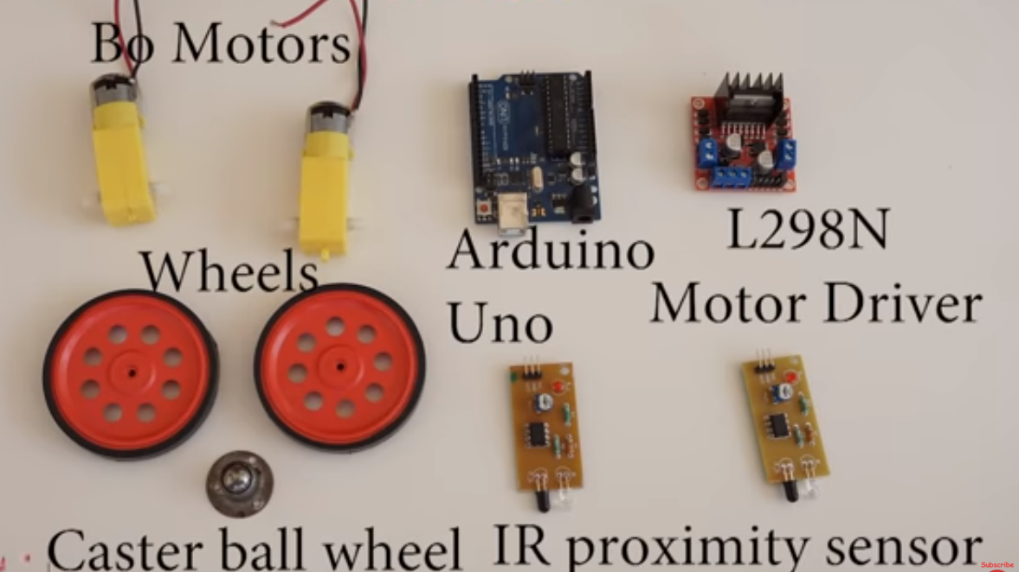

**Implementation of Robot:**

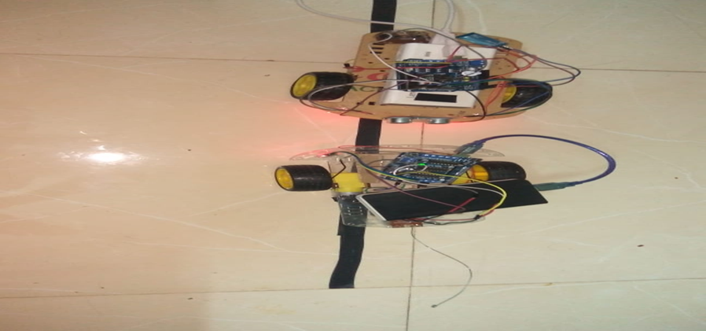

**Robot is following the Line:**

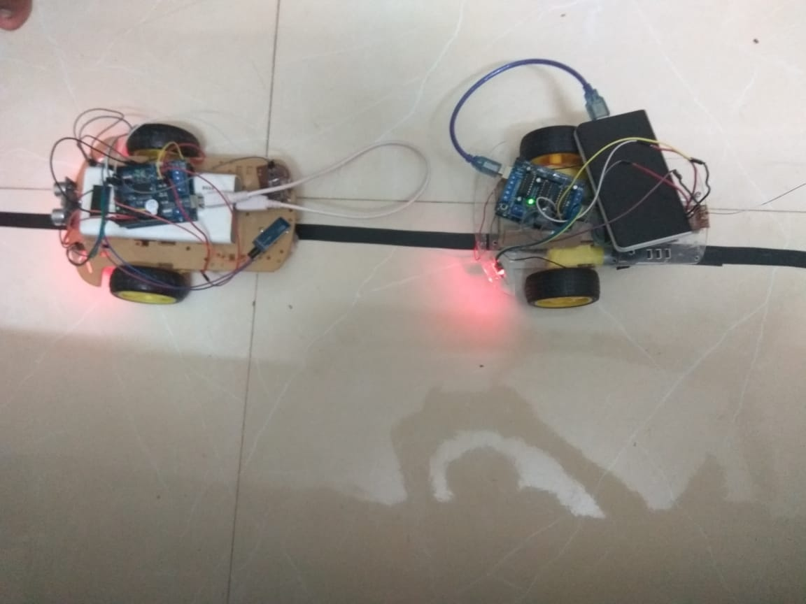

**Robot is avoiding the obstacles:**

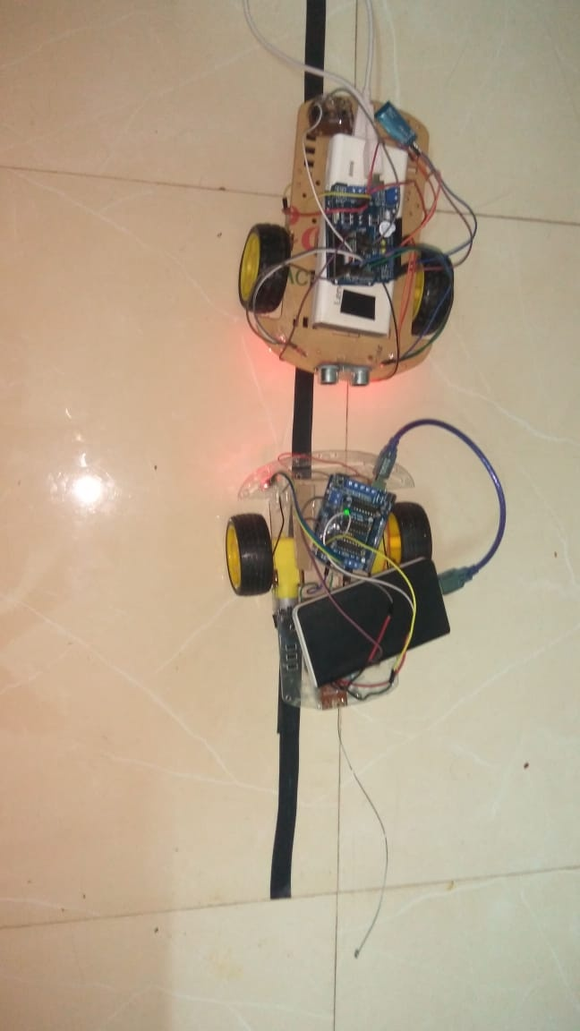

1. **Conculsions and future scope**

The goal of our project is to create an autonomous robot which intelligently detects the obstacle in its path and navigates according to the actions that we set for it. So what this system provides is an alternate to the existing system by replacing skilled labor with robotic machinery, which in turn can handle more patients in less time with better accuracy and a lower per capita cost.

This smart and intelligent robot can be modified and controlled using Bluetooth, WIFI module and other type of sensors. The movement of the line follower can be controlled either by using a Bluetooth or a WIFI module. By using any of these modules, the line follower robot can be stopped, can be turned right and can be turned left. This makes the line follower robot more intelligent and useful. The line follower cannot be stopped on its path if a Bluetooth or WIFI module is not used. So to stop the robot without placing any other obstacle this idea can be implemented to stop the robot or even to change its path.

**References**

1. Inteligent Line Follower Mini-Robot System Román Osorio C., José A. Romero, Mario Peña C., Ismael López-Juárez, International Journal of Computers, Communications & Control Vol.
2. Development and Applications of Line Following Robot Based Health Care Management System by Deepak Punetha, Neeraj Kumar, Vartika Mehta, International Journal of Advanced Research in Computer Engineering & Technology.
3. OBSTACLE AVOIDING ROBOT – A PROMISING ONE Rakesh Chandra Kumar1 , Md. Saddam Khan2 , Dinesh Kumar3 ,Rajesh Birua4 ,Sarmistha Mondal5 , ManasKr. Parai6.
4. M.Zafri Baharuddin, "Analyst of Line Sensor Configuration for Advanced Line Follower Robot", University Tenaga Nasional.
5. Robotic Competition Rolls site: <http://www.tjrc.ir/roles.asp>
6. line follower report / controlled robot,<http://www.robokitsworld.com>
7. <http://www.ti.com/lit/ds/spms150g/spms150g.pdf>
8. <http://www.st.com/internet/analog/product/63147.jsp>